Joshua

Partial Occupation of Canaan

Conquered |  | Settled
Chapters 1–12 |  | Chapters 13–24
Swords |  | Spoils
Faith Demonstrated |  | Faith Rewarded
Entering  Canaan | Conquering  Canaan | Dividing  Canaan
Preparation | Subjection | Possession
Jordan River | Canaan | 2 1/2 Eastern Tribes  9 1/2 Western Tribes
ca. One Month | ca. 7 Years | ca. 18 Years
Preparation  (1–5) | Process  (6–12) | Partitioning  (13–21) | Principles  (22–24)

Key Word: Occupation

Key Verse: “Do not let this Book of the Law depart from your mouth; meditate on it day and night, so that you may be careful to do everything written in it. Then you will be prosperous and successful” (Joshua 1:8)

Summary Statement:
The way Israel conquered and settled most of Canaan was by courageous faith that God would fulfill his promise.

Applications:

Obedient faith based upon God's promises brings blessing.

Partial obedience results in difficulty.

Joshua

Introduction

I. Title The Hebrew and English names for the book are the same. Joshua ([:vuAhy> Yehoshua) literally means "Yahweh saves" or "Yahweh is salvation" (BDB 221c 1). His original name was Hoshea, "salvation" (Num. 13:8), but Moses changed it to Yehoshua, "Yahweh is salvation" (Num. 13:16), which is the Hebrew equivalent for the Greek name Iesous, Jesus. This is a good title since Joshua appears as the main character and his mission as leader of Israel is to help the people understand that God, not he, saves them by conquering the Canaanites and apportioning their land to them.

II. Authorship

A. External Evidence: Jewish tradition ascribes the work to Joshua himself. The Talmud says that Joshua wrote all but the last five verses which Phineas recorded.

B. Internal Evidence: The text claims that Joshua wrote at least parts of the book (8:32; 24:26). Several lines of evidence point to a very early composition: (1) The author is an eyewitness to the events as "we" and "us" describe the participants (5:1, 6), (2) Rahab was still living (6:25), (3) The Jebusites still inhabited Jerusalem (15:63), and (4) Old names of the Canaanite cities are employed (e.g., Kiriath Arba for Hebron in 15:13).

However, although the unity of style and organization suggest a single author, three sections must have been written after Joshua's death: (1) Othniel's capture of Kiriath Sepher (15:13-19; cf. Judges 1:9-15), (2) The northern migration of the tribe of Dan (19:47; cf. Judges 18:27-29), and (3) Joshua's death and burial (24:29-33). Many evangelical scholars attribute these minor additions to Eleazar the priest and his son Phineas (24:33) during the time of the judges.

Joshua was born a slave in Egypt into the "half-tribe" of Ephraim, was redeemed from slavery at 40 years old (Moses' "young aide"; cf. Exod. 33:11), began leading Israel at 80 years old, and led the nation for 30 years until his death at the age of 110 (24:29).

III. Circumstances

A. Date: The date of the conquest of Canaan hinges, of course, upon the date of the Exodus (see Exodus notes for support of the early date of ca. 1446 BC). Caleb was age forty at Kadesh one year after the Exodus (14:7; 1445 BC) and eighty-five at the conclusion of the conquest (14:10). Since this 45 year difference included 38 years of wanderings, it leaves a seven year conquest from 1405-1398 BC (the wanderings being from 1445-1405 BC). This places the entrance into Canaan at 1405 BC and the conclusion of the Book of Joshua seven years later in 1398 BC. Joshua died many years later at the age of 110 (23:1; 24:29). Some believe he died only eight years later (cf. TTTB, 53, and Schmidt's chronology chart "Old Testament Patriarchs and Judges") but a more reasonable guess is about ten to twenty years later (Campbell, BKC, 1:367). Therefore, the Book of Joshua, apart from minor additions, was written after 1398 and perhaps as late as 1378 BC.

B. Recipients: The first readers of Joshua were Israelites in Canaan with him after the land conquest.

C. Occasion: Moses had just died after leading Israel in forty years of wilderness wanderings. Then Joshua took the helm to lead the nation to take possession of the land God had promised. One teacher has noted that if the second book of the Bible is properly called Exodus ("the way out"), then this sixth book may be deemed Eisodus ("the way in")! In this book the nation experiences the partial fulfillment of the promise of the land that stems all the way back to Abraham nearly 600 years earlier (cf. Gen. 12:1, 7).

IV. Characteristics

A. Joshua marks a new method of God's communication to his people. Up to this point (i.e., in the Pentateuch) Jehovah spoke through dreams, visions, or angels. However, beginning with Joshua, the Law of Moses becomes the voice of God in written form (1:8). The importance of the written word is emphasized in the examples and commands to obey it (1:7, 8c; 23:6-16), talk about it (1:8a), meditate upon it (1:8b), honor it (8:32-33), and read it (8:34-35).

B. In the Hebrew canon the Book of Joshua heads the grouping of books called the "Prophets." The reason for this is debated, but some suggest that Joshua held the office of a prophet. Others understand the placement as indicating that this book (among the "Former Prophets") illustrates the principles preached by the prophets (Campbell, BKC, 1:325).

C. Joshua records the incomplete possession of the land. Although land ownership was unconditional (Gen. 12:7; 15:18-21; 17:8), possession was conditional (Deut. 29:9–30:20). While God promised the entire land of Canaan (1:4), the Israelites did not possess it all because they did not trust God for it all (13:1). Therefore, the Land Covenant that promises the land from the Wadi of Egypt to the Euphrates River (Gen. 15:18) was not fulfilled under Joshua. In fact, it still remains unfulfilled.

D. Many common themes connect Deuteronomy and Joshua:

Theme Deuteronomy Joshua

Holy War How to do it (instructed) How it was done (implemented)

Possessing Canaan Promised Possessed

Joshua's Role Appointed Operated

Law of Moses Stated Restated (Josh. 23–24)

Argument

The Book of Joshua divides easily into two parts. Both show the partial occupation of the Promised Land by Israel in fulfillment of God's promise. The first part (Joshua 1–12) records how the nation conquers most of the land of the Canaanites through a careful preparation (Joshua 1–5) and exploits through Joshua's faith in God (Joshua 6–12). The second part (Joshua 13–24) describes how Israel settles the conquered land by partitioning it into allotted areas for the respective tribes (Joshua 13–21) and how this land stays settled by obedience to the covenant (Joshua 22–24). The purpose of each of these sections is to instruct the nation that obedient faith based upon God's promises brings blessing.

Synthesis

Partial Occupation of Canaan Partial fulfillment of the land promise

1–12 Land conquered
1–5 Preparation
1 Charge
2 Spies
3 Jordan crossing
4 Memorial
5:1-12 People prepared: Ceremonies
5:13-15 Joshua prepared: Angel
6–12 Process
6–8 Central: Jericho, Ai
9–10 Southern: Gibeonites, Amorites
11:1-15 Northern: Coalition
11:16–12:24 Summary

13–24 Land settled
13–21 Partitioning
13:1-7 Philistia not allotted
13:8-33 Eastern (2 1/2)
14:1–19:48 Western (9 1/2)
14–15 Judah: Caleb, rest
16–17 Joseph
18:1–19:48 7 tribes
19:49–21:45 Joshua, manslayers, Levites
22–24 Principles
22 Civil war averted: unity
23:1–24:27 Covenant renewal: obedience
24:28-33 Burials: faith

Outline

Summary Statement for the Book
The way Israel conquered and settled most of Canaan was by courageous faith that God would fulfill his promise.

The way Israel conquered most of Canaan was by courageous faith that God would fulfill his promise (Joshua 1–12).

Israel prepared to occupy Canaan through obeying Joshua's military and spiritual leadership as an example of trust in God and his leaders (Chs. 1–5).

God told Joshua to courageously conquer the land in his strength founded in God's Word (Ch. 1).

Joshua gained courage through two spies who gave the report of Rahab’s faith (Ch. 2).

Joshua trusted God by miraculously crossing the Jordan to teach Israel to trust God and his leaders (Ch. 3).

Israel built a memorial of their miraculous Jordan crossing so they would not forget God's work on its behalf (Ch. 4).

Joshua prepared Israel spiritually to separate the people as committed to trust in God's promises (5:1-12).

The preincarnate Jesus prepared Joshua for conquest to show God as Israel’s main leader (5:13-15).

Israel conquered each region of Canaan separately in step-by-step trust in God's sovereign leading to enjoy his promised blessing (Chs. 6–12).

The conquest of central Canaan in Jericho and Ai showed how obedience leads to God’s blessing (Chs. 6–8).

Israel miraculously and unusually defeated Jericho against tremendous odds to teach the nation that it must obey God's plan for victory (Ch. 6).

The initial defeat of Israel by Ai before Israel finally conquered the city points out how sin among the people prevents them from experiencing God's deliverance (Chs. 7–8).

The conquest of southern Canaan shows the need to trust in God—not self—for victory (Chs. 9–10).

The foolish covenant to spare the deceptive Gibeonites shows the need to trust God instead of human wisdom (Ch. 9).

God’s defense of the Gibeonites by hailstones and prolonged daylight defeated the Amorites and southern Canaan to show that only obedient faith brings victory (Ch. 10).

The conquest of northern Canaan’s coalition of armies shows God’s sovereign hand to fulfill his promise (11:1-15).

A summary of the conquest shows that God fulfilled his promise for Israel to possess every place where they stepped (11:16–12:24; cf. 1:3).

The result of Israel’s courageous faith was that they settled Canaan (Chs. 13–24).

Israel's partitioning the occupied Promised Land for each tribe, Joshua, manslayers, and Levites teaches the joyful rewards of faith and obedience (Chs. 13–21).

The coastal regions were not allotted to any tribe since Israel failed to conquer these areas to show that Israel possessed only land where they set foot according to the promise of God (13:1-7; cf. 1:3).

Portions for the two and one-half eastern tribes show that they kept the national unity as they fought for the other tribes just as those tribes fought for them (13:8-33).

Portions for the nine and one-half western tribes show Israel the joyful rewards of faith and obedience (14:1–19:48).

Land for Judah, Joseph, and half of Manasseh came by lot in Gilgal (Chs. 14–17).

Judah got land across southern Canaan from the Dead Sea to Philistia (Chs. 14–15).

Caleb occupies a portion in southeastern Judah (Ch. 14).

The rest of Judah’s boundaries stretch from the Dead Sea to Philistia in every area except the Jebusite city of Jerusalem (Ch. 15).

Joseph got Ephraim and the half-tribe of Manasseh’s land in central Canaan from the Jordan River to the Mediterranean Sea (Chs. 16–17).

Land for the other seven tribes came by topographical survey and by lot in Shiloh (18:1–19:48).

The remaining tribes moved to Shiloh where a topographical survey was added to the casting of lots to determine inheritances (18:1-10).

Allotments for Benjamin, Simeon, Zebulun, Issachar, Asher, Naphtali, and Dan finish the undesignated land portions (18:11–19:48).

Land for Joshua, manslayers, and Levites show the joyful rewards of obedient faith (19:49–21:45).

Joshua gets the city of Timnath Serah in the hill country of Ephraim (19:49-51).

Six cities of refuge among Levite towns protect manslayers of accidental deaths until standing trial and until the high priest’s death (Ch. 20).

Forty-eight Levite towns spread the teachers throughout the land rather than giving them one geographical inheritance (Ch. 21).

Israel's emphasis on unity, obedience, and faith motivate a covenant renewal for continued occupation of the Promised Land (Chs. 22–24).

The western tribes almost go to war against the eastern tribes, who build a memorial altar to encourage worship at the LORD’s sanctuary, to stress the importance of unity in Israel (Ch. 22).

Joshua's charge to covenant renewal before his death insists that covenant obedience is the basis for continued occupancy of the land (23:1–24:27).

An appendix, probably by Phineas, records that Joshua, Joseph, and Eleazar all once lived in Egypt yet were buried in Canaan to faith in God's faithfulness to keep his promises (24:28-33).

Miraculous Crossings

Reed (Red) Sea | Jordan River
Exodus 14 | Joshua 3
A Sea | A River
Moses | Joshua
Begins the Wanderings | Ends the Wanderings
Leaving Egypt | Leaving Moab
Entering Sinai | Entering Canaan
Egyptians Killed | No-One Killed
Song Memorial (Exod. 15) | Stone Memorial (Josh. 4)
Narrow Channel (Exod. 14:22) | 30 Km Plain (Josh. 3:16)
Took All Night | Took a Few Hours
Pillar Led the Way | Priests Led the Way
Circumcision Preceded | Circumcision Followed
Passover Preceded | Passover Followed
Complaining Followed | Conquering Followed
Gave Freedom | Gave Rest*
Signifies Salvation | Signifies Glorification
Antitype is Christian Life | Antitype is Kingdom Life
2 Million People | 2 Million People
10th day of 1st Month (Exod. 12:2-3)  = 10 Nisan 1445 BC | 10th day of 1st Month (Josh. 4:19, 23)  = 10 Nisan 1405 BC

* Josh. 1:13, 15; 22:23b; 14:15; 21:44; 22:4; 23:1

Battles of Joshua’s Conquest

John H. Walton, Chronological and Background Charts of the OT, 2d ed., 38

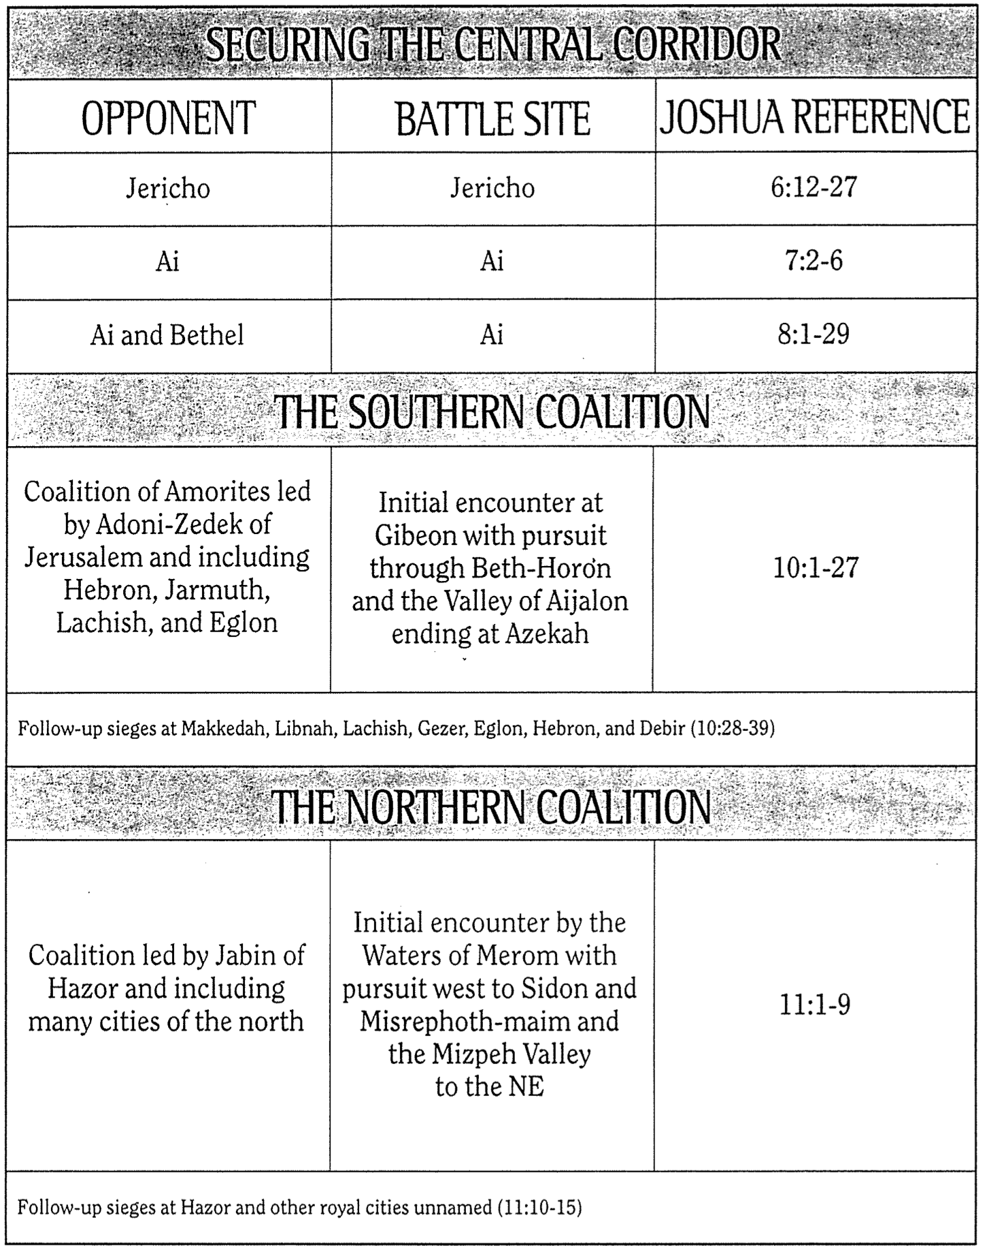

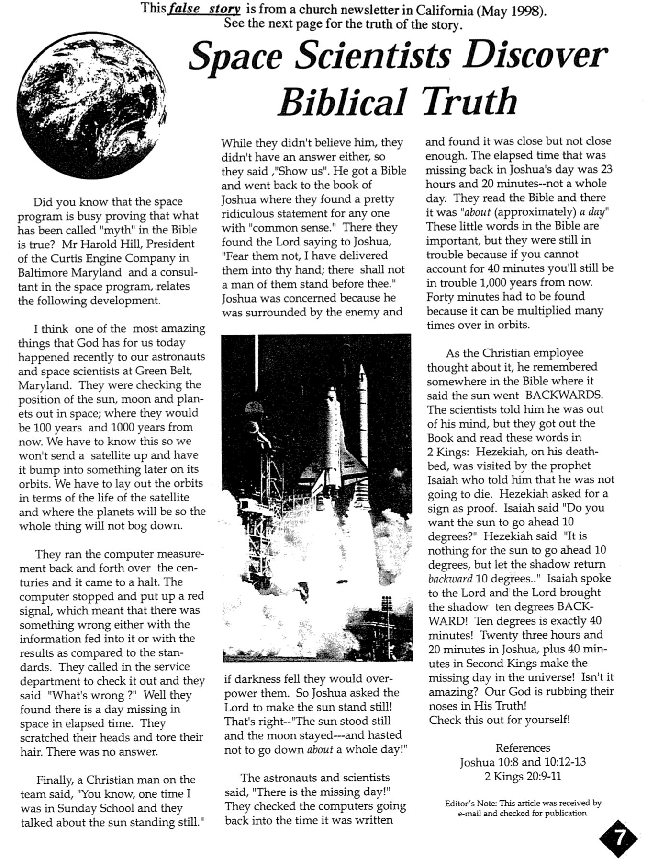
This false story is from a church newsletter in California (May 1998).
See the next page for the truth of the story.

The Harold Hill Myth

From: KBertsche@aol.com
Subject: Harold Hill Myth
Date: Sun, 7 Jun 1998 19:46:26 EDT

I have received four e-mails repeating the "Harold Hill Myth" in the past month, so thought it warranted a detailed response. Please forward this message to anyone who sends the story to you, anyone you have sent it to, or anyone you think may be influenced by it. The "Harold Hill Myth" is a Christian "urban legend" which has been circulating for some 30 years now in its present form. It is based on a book published more than 100 years ago, in 1890. It has recently started making its way around the Internet.

The story by Harold Hill tells about NASA scientists who were back-calculating the positions of celestial bodies, and their computers balked at inconsistencies in the calculations until a Christian in the crowd persuaded them to insert the missing day of Joshua [Josh. 10:8, 12-13] and the missing 40 minutes of Hezekiah [2 Kings 20:9-11], which made the computers happy and verified these biblical miracles [see previous page for the full story].

Firstly, this is complete, utter nonsense! In calculating to find the motion of heavenly bodies, there is no way of telling whether days, hours, or months were missing in the past. The equations will happily run forwards or backwards, ignorant of these things. Without an external reference to compare the calculations to no one will know that they are calculating incorrect positions when the equations are run backwards.

Secondly, the source of the story is highly dubious. The account is denied by NASA. While there is indeed a Harold Hill who recounts this story, he had only a VERY peripheral contact with NASA. Believers who have investigated the story have uncovered his dubious connection to NASA, and an older, very similar story by Rimmer in 1936 (long before NASA), claiming to be based on Totten's book in 1890 (more than 100 years ago!), which was apparently not based on any celestial calculations. It seems that this is an old story which has been embellished over the years, and that the celestial mechanics and NASA connection has absolutely no basis in fact.

It is very disappointing to me that in our modern, sophisticated, scientific society, people can still be duped by such nonsense. I don't know if this indicates the poor state of science education in this country or the reluctance of Christians to think critically (probably some of each). We need to be "as wise as serpents" (Mt. 10:16), and skeptical of such accounts. We do not want or need to resort to lies to support the truth of the Scriptures! As James Kiefer says of this myth, "MORAL: When you encounter stories that appear to confirm the truth of the Christian faith, and you cannot trace them back to a reliable source, or when there are unanswered questions like 'How do we know this?', it is best, in evaluating them, to err on the side of too much skepticism rather than too little."

Kirk Bertsche, PhD

________

Note: Dr. Bertsche has a PhD in Physics and was studying at Western Seminary, San Jose, CA when he wrote this email in 1998. For more information, he gives these links (updated on 2 April 2012 from his email):

http://www.snopes.com/religion/lostday.asp
http://www.57piano.com/scispks.htm#Mark11
http://imagine.gsfc.nasa.gov/docs/ask_astro/answers/970325g.html (Note: this last reference has good science, but betrays a low and overly restrictive view of biblical truth.)

Conquest of Canaan
The Bible Visual Resource Book, 45

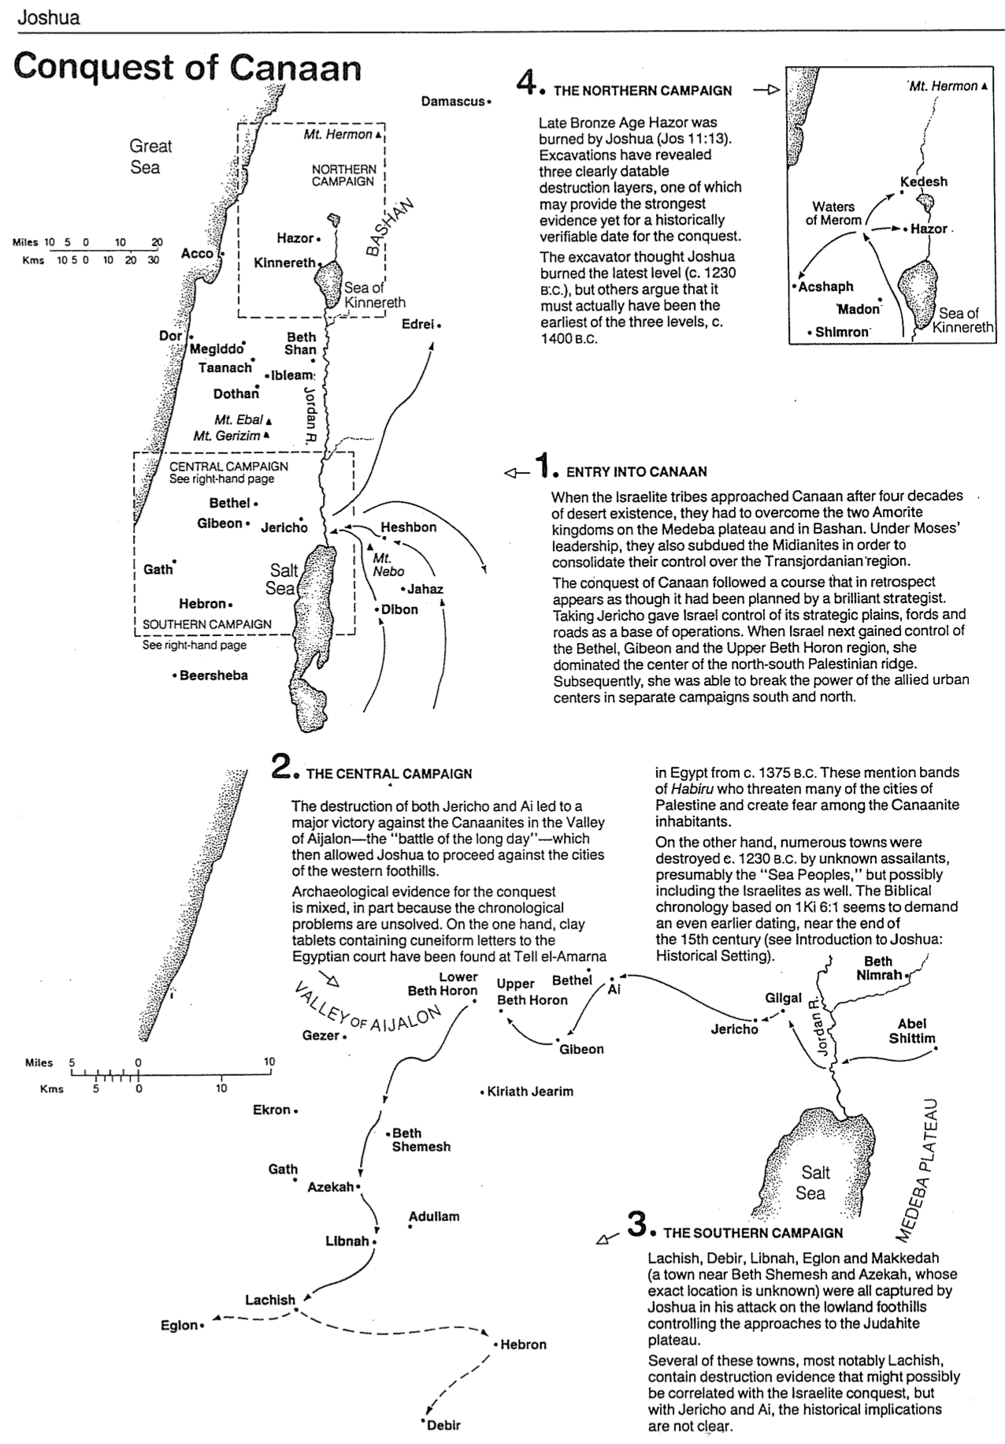

Division of Canaan

Irving L. Jensen, Jensen’s Survey of the OT, 140 (adapted based on Barry Beitzel, Moody Atlas of Bible Lands, 100)

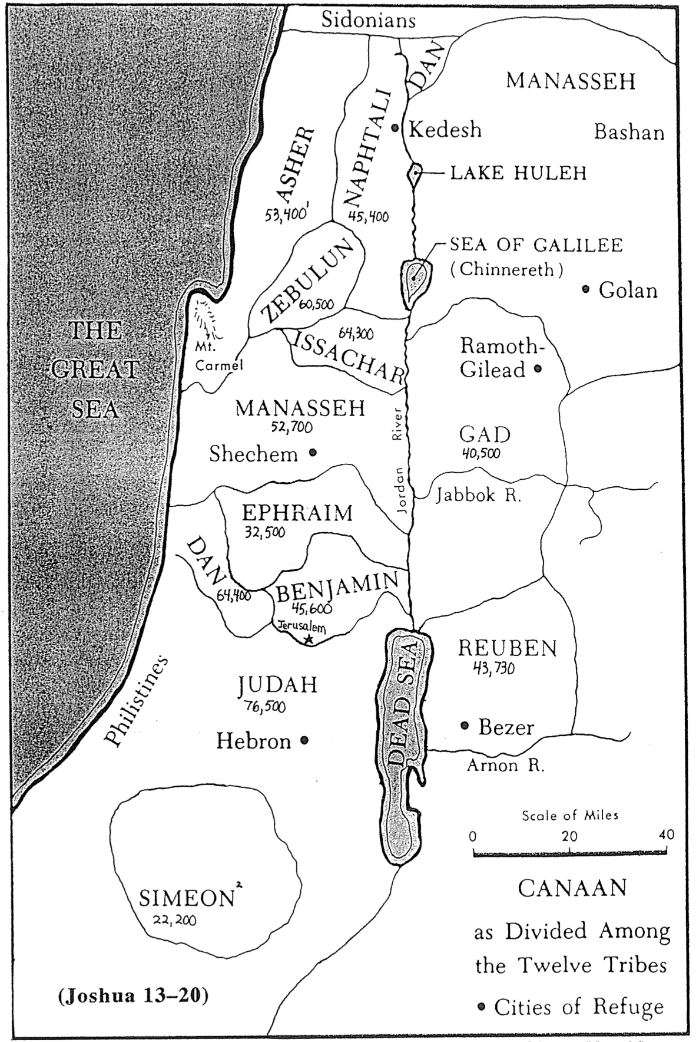

(Joshua 13–20)

¹ Numbers for each tribe indicate the population of soldiers just before the conquest of Canaan (Num. 26).
² Simeon’s inheritance lay within the land of Judah (Josh. 19:1-9) due to his violence at Shechem (Gen. 34:25-31).
Levi also received no inheritance except cities within other tribes (cf. p. 171a) due to the same sin (Gen. 49:5-7).

Levitical Cities and Cities of Refuge
Barry Beitzel, Moody Atlas of Bible Lands, 101

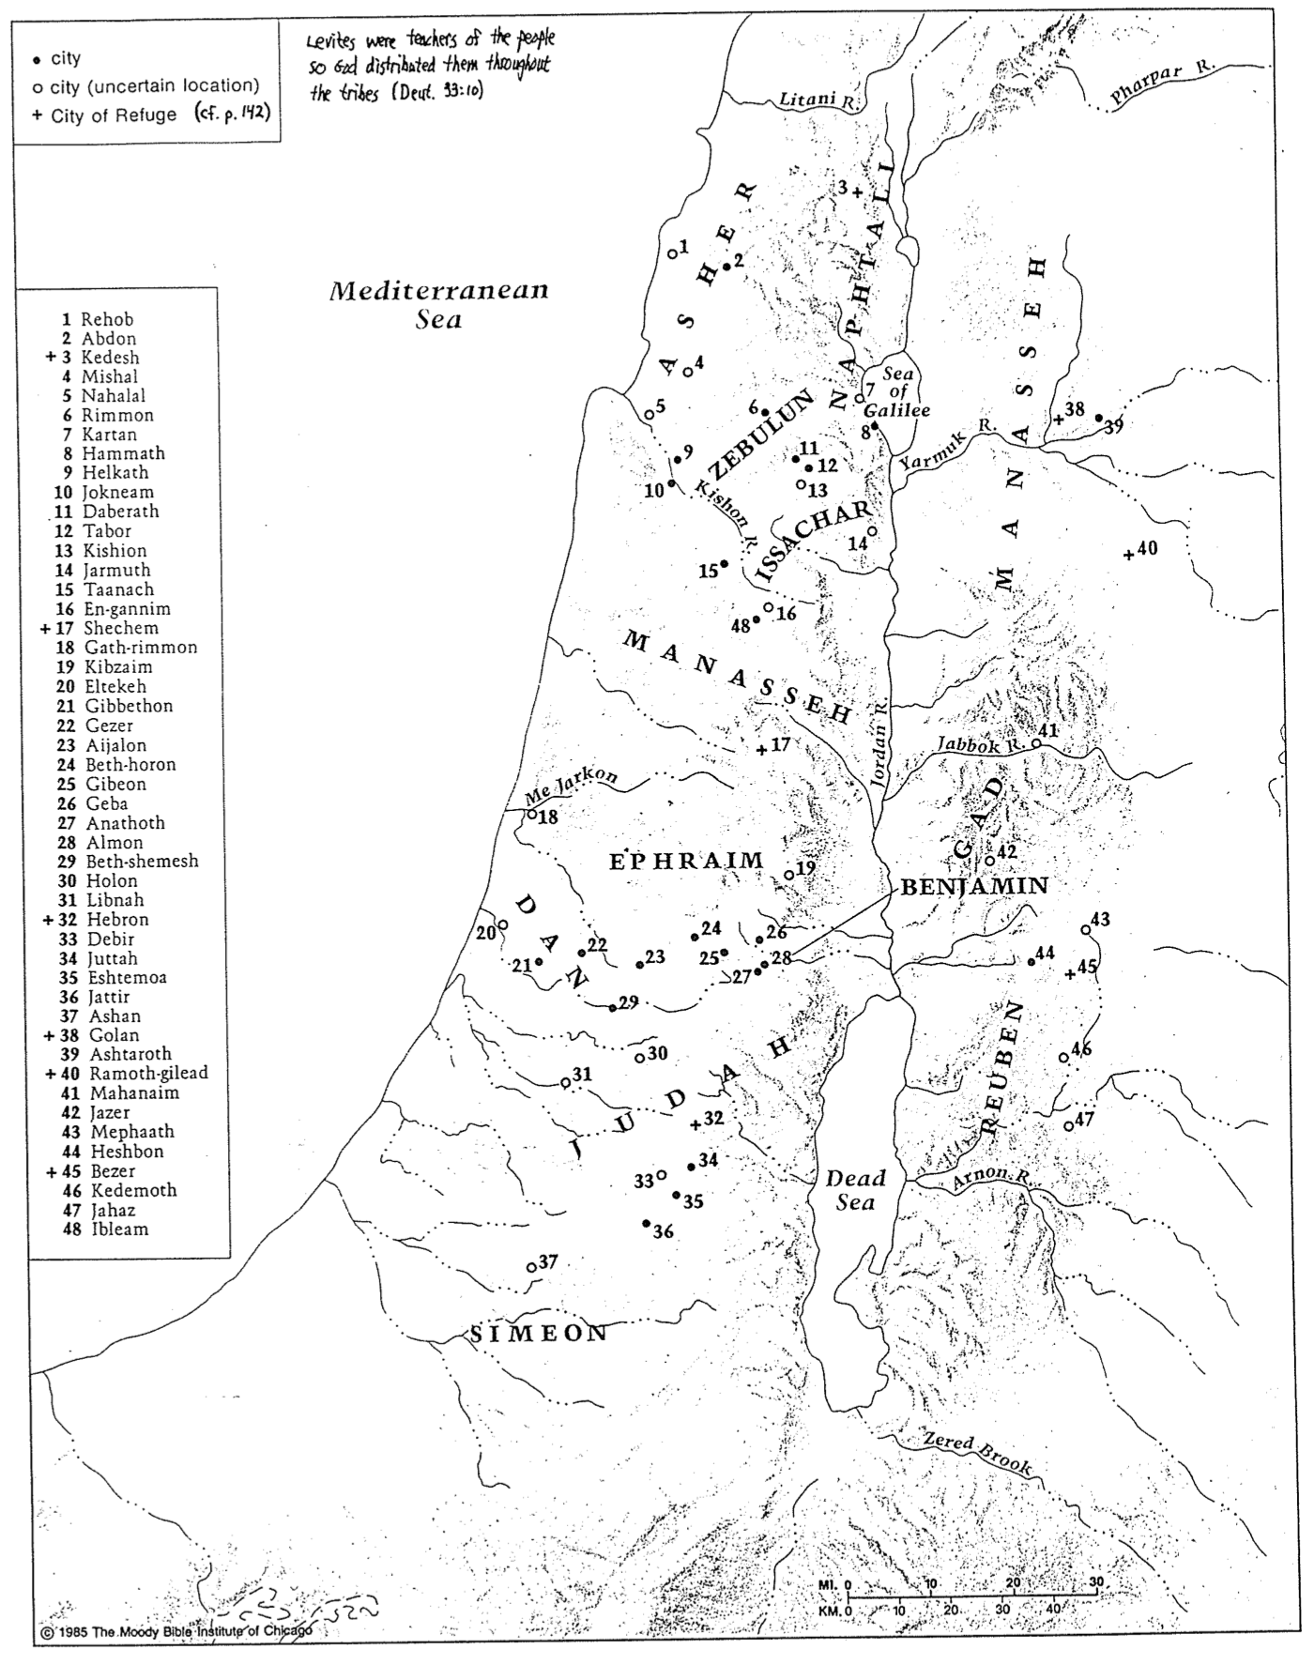

Issues about Jericho

1. Is Jericho the Oldest City in the World?

Most archaeologists believe Jericho is the world’s oldest city (8000 BC), even before pottery was made. However, the actual oldest city more probably would be Babylon in Iraq where the tower of Babel was built (Gen. 11). The genealogies of Genesis 5 and 11 at face value (no gaps) lead to creation at 4143 BC anyway (p. 84). A date no later than 4000 BC for settlements on the site (not a full-fledged city) is supported by the excavations of British professor and archaeologist John Garstang. He unearthed five layers of cities at Jericho from 1930-1936 and published a definitive work in The Story of Jericho (London: Marshall, Morgan & Scott, 1940; rev. ed., 1948). However, either proposed date (8000 or 4000 BC) would precede the flood at about 2500 BC (p. 90).

2. What made Jericho so Significant?

Jericho’s strategic location guards the pass to the hills of Judah and across the Jordan River, as well as the north-south route of the Jordan Valley. Due to this location, some believe Jericho has been built and destroyed 23 times! It is also called City of Palms (Deut. 34:3; “Jericho” means “fragrant place”), as it lies in the fertile Jordan oasis rich in fruits and vegetation (not watered by rain). The OT site of Joshua 6 is Tell es-Sultan, a 400-meter mound arising 15 meters from the bedrock. Immediately to the east is the spring of Ain es-Sultan that waters the oasis. This is likely the fountain of Elisha (2 Kings 2:19-22). Behind Jericho is Jebel Kuruntul or Mount of Temptation where tradition records Christ’s temptation by Satan for 40 days (Matt. 4; Luke 4).

3. Did God Bless Rahab’s Lie?

Rahab actually lied in several ways. She said she didn’t know where they men had come from, she said they had left, and she said she didn’t know where they went (Josh. 2:4-5). Does the end (saving the lives of the spies) justify the means (lying)?

Several items can be said in response:
1. God never said that he approved of her lying. He only approved of her faith (Heb. 11:31).
2. God could have still saved the lives of the spies and Rahab even if she told the truth.
3. “At most, God allowed his purposes to be fulfilled in this unusual manner because his grace can operate in spite of the sinful maneuverings of man” (Kaiser, Hard Sayings of the OT, 97).

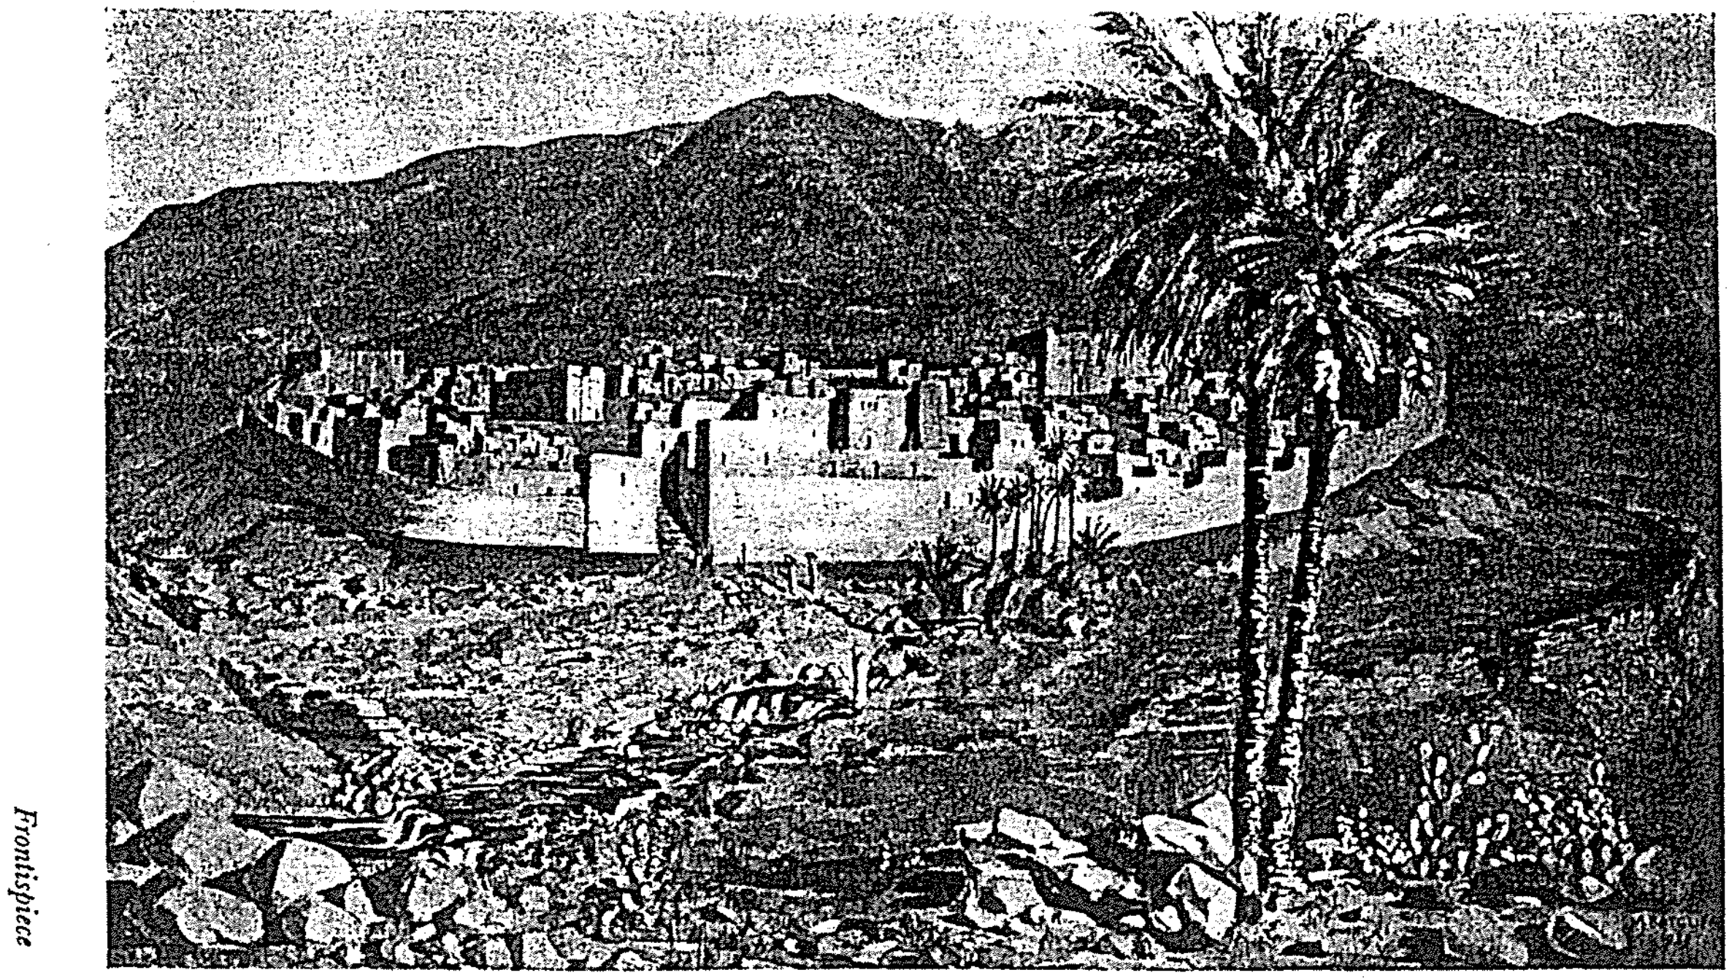

An Artist’s Impression of the Fourth City of Jericho in the Time of Joshua (1400 BC)
This is how Israel saw the city from the east. Note the spring in front of the city as well as remains of the third city. Houses rose on the west side behind imposing walls with the king’s palace in the middle and temple southwest.

4. Is There Evidence that Jericho’s Wall Collapsed?

John Garstang (see earlier) surveyed the evidence for the destruction of the fourth city (Layer D) and concluded Joshua destroyed Jericho between 1426 and 1385 BC. He notes that about 100 years earlier, Jericho had two walls constructed: a 12-foot thick inner wall of mud-brick, plus a 6-foot thick outer wall (pp. 135-36). The walls were so strong that overcrowding in the city motivated people to build homes bridging the two walls (Josh. 2:15). A field report shows evidence of burning (Josh. 6:24) in “reddened masses of brick, cracked stones, charred timbers and ashes” (p. 136). Ancient walls typically crumbled on themselves or towards a city from battering rams; yet note below in Garstang’s cross-sectioned drawing how both walls fell away from the city:
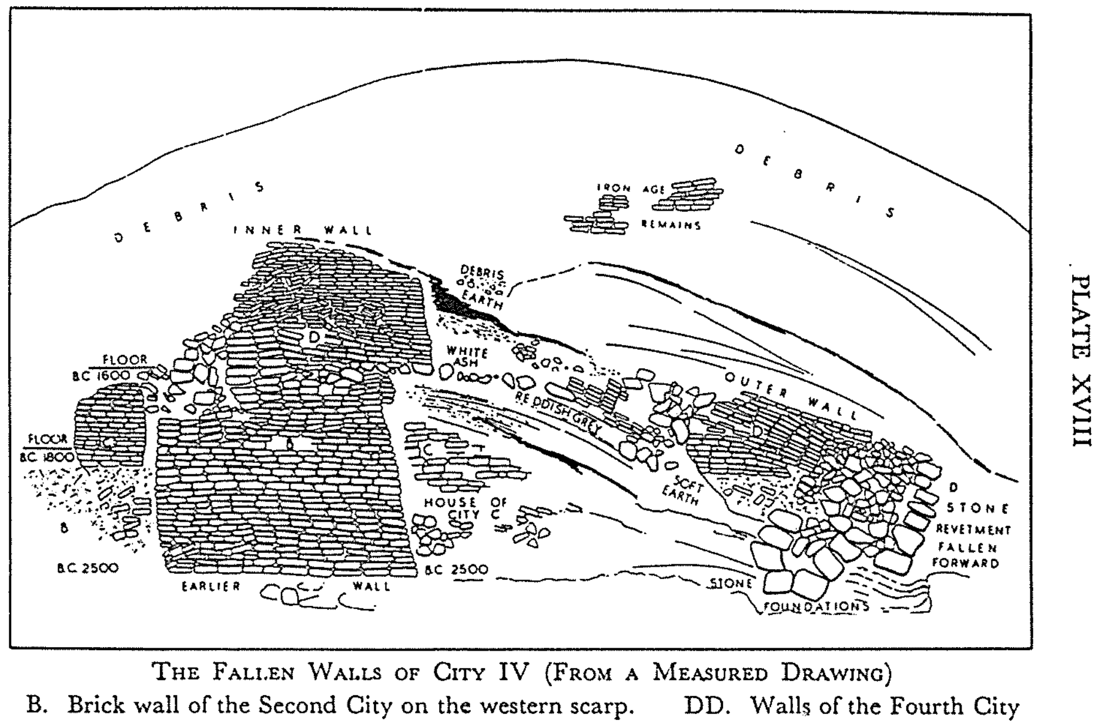

“What then could account for so stupendous a catastrophe?” Garstang writes. He dismisses trampling of feet, a loud shout, trumpets, and tunneling–then concludes (p. 138):

One conclusion indeed seems certain: the power that could dislodge hundreds of tons of masonry in the way described must have been superhuman. Earthquake is the one and only known agent capable of the demonstration of force indicated by the facts; and there is reason to believe that in this lies the real answer to our question.

Garstang then cites a dozen earthquakes in this area from ancient to modern times.

These findings, of course, have found opponents in advocates of a late date exodus (1280 BC) such as G. E. Wright and W. F. Albright. Kathleen Kenyon (Digging Up Jericho, 1957) later advocated that the wall fell and the city was burnt at various times in its history (see J. A. Thompson, The Bible and Archaeology, 2d. ed., [Eerdmans, 1973], 60-61). Yet Garstang had noted that burning normally did accompany destructions, but the City D level was unusually large (p. 142), as would be expected when the city was not plundered first (Josh. 6:24). Finds include huge supplies of food.

5. How Could a Loving God Command the Killing of Canaanites?

God told Israel to conquer Jericho and the Canaanite cities by not leaving anything alive that breathes (Deut. 20:16-17), so they killed men, women, babies, and animals (Josh. 6:21; 8:26; 10:28; 11:11). Yet in the NT we find God as a loving God. Jesus even said to turn the cheek towards violence (Matt. 5:39). How can we reconcile these seemingly contradictory commands?

- God is always the same God. He is a God of love in the OT as seen in his many acts of grace; He is also a God of wrath in the NT (Rom. 1:18). He even waited 400 years until the sin of the Amorites (Canaanites) “reached its full measure” (Gen. 15:16)–that is, they bore their own sin.
- God showed love to the world by protecting Israel and the world from Canaanite influences (Deut. 20:16-18), including their child sacrifice, homosexuality, bestiality, etc. (Benware, 276).
- Only radical surgery can save bodies from cancer. Is such surgery inhumane (Gen. 6:5)?
- We have resources against corruption that Israel lacked (Rom. 6:13; 1 Cor. 6:19; 2 Cor. 10:4-5).

